Server :

Server Started, and waited for client request to established the connection.

Once a get command fired from client with multiple files as argumnets, it receives those files and spawns a new thread (child process) for each files and start writing to the shared memory and loop does for all files currently for each files.

As you can , three files has been sent from client and received by the servers, so three threads has been created and start working its concurrently and once finished its operations it sends the line to the client via shared memory.

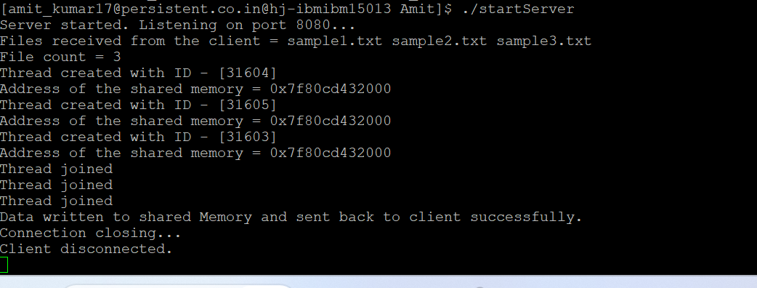

Client :

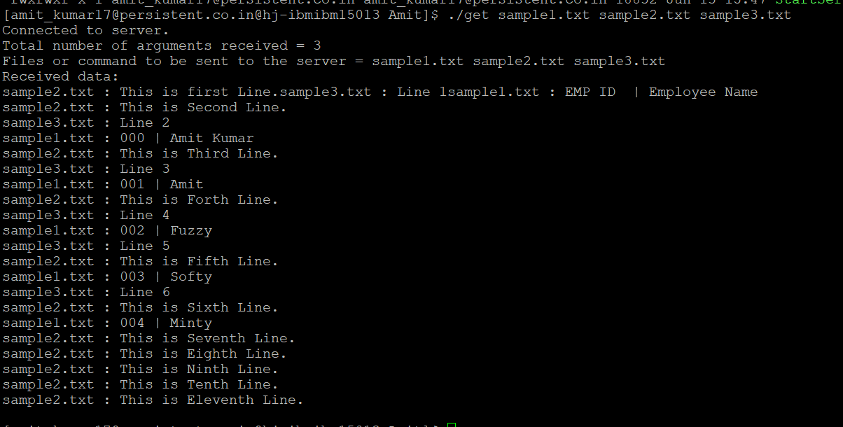

Exit command to stop the server.

---------------------------------------------------------

[amit_kumar17@persistent.co.in@hj-ibmibm15013 Amit]$ ./get exit

Connected to server.

Total number of arguments received = 1

Files or command to be sent to the server = exit

Error: Server is closed!!!: Success

[amit_kumar17@persistent.co.in@hj-ibmibm15013 Amit]$

